Booster’s Dashboard

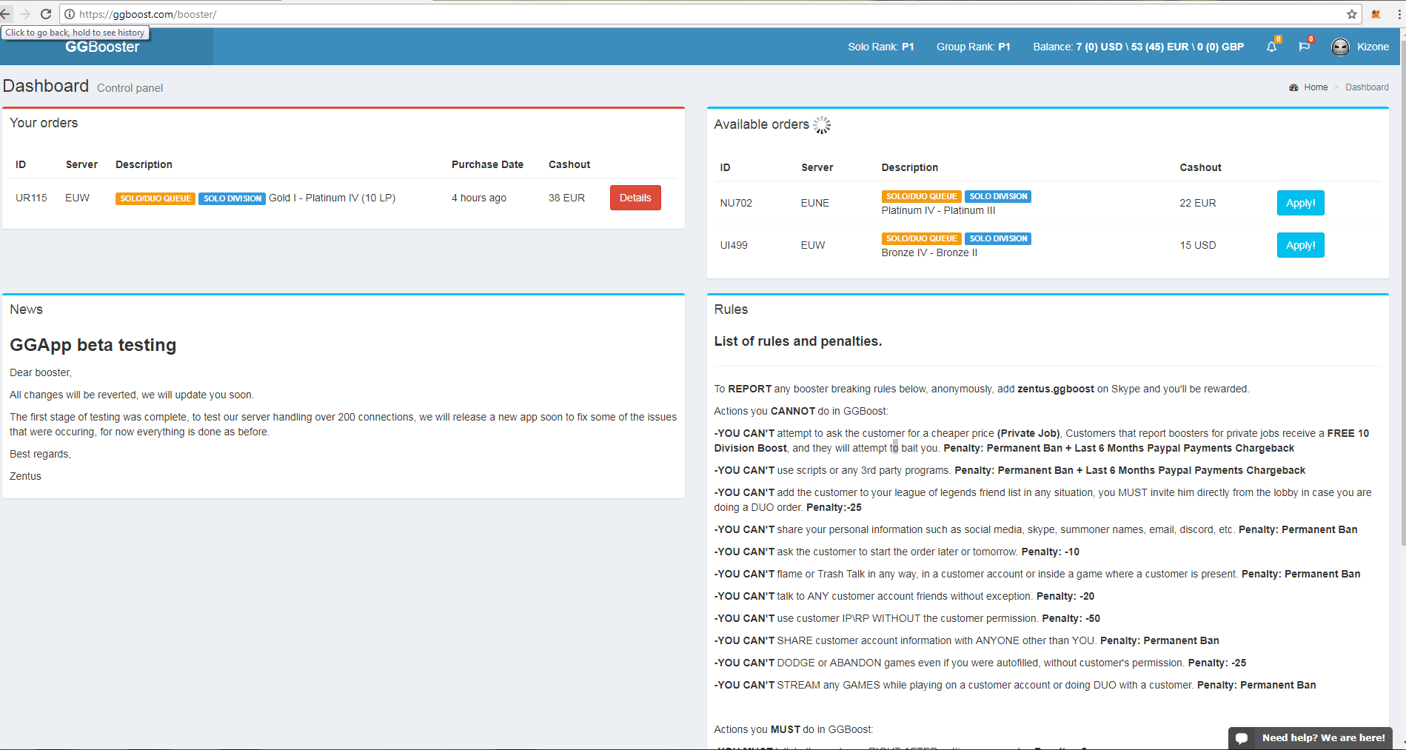

1. Claimed orders A booster can have 1 Solo order and 2 Duo-Queue order at a time but no more, but should be adjustable by admins. An order should have an Order ID, Given server, Order description, purchase date and Cashout.
2. Available orders In this area the website needs to refresh every 5 or 10 seconds to update the available orders list. A booster can apply if he doesn’t have any order limits at the moment. 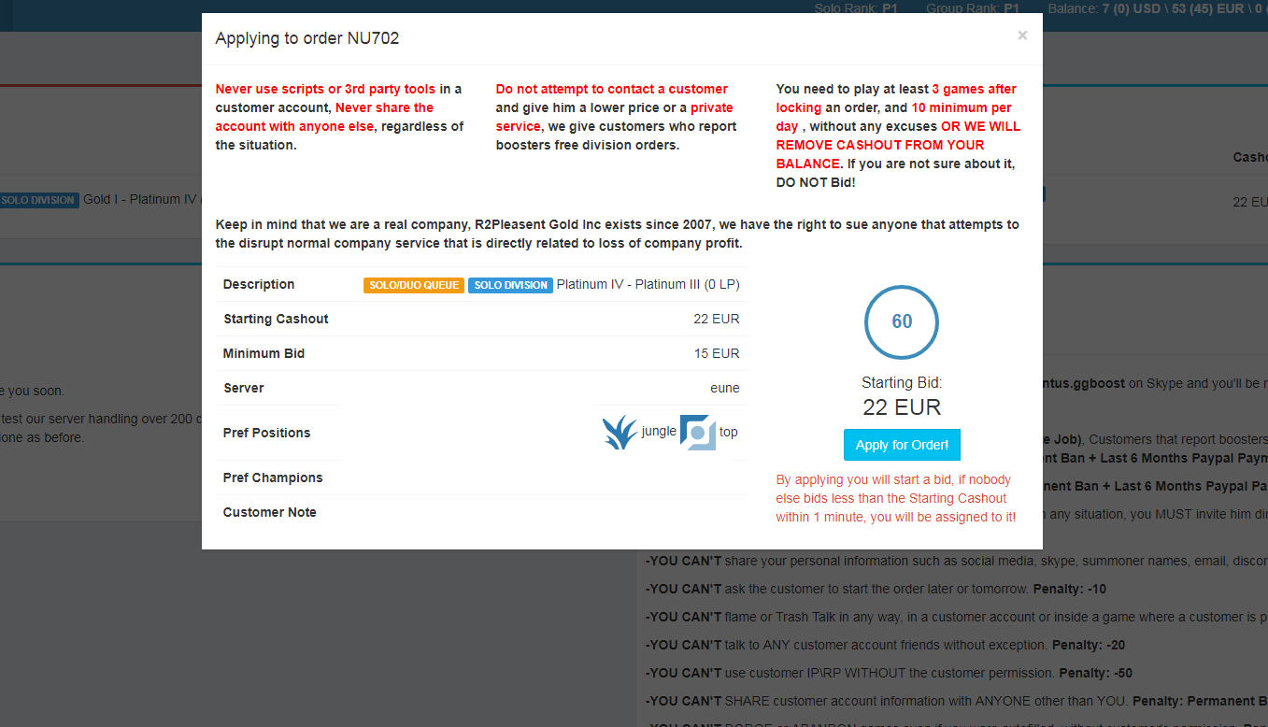 To claim the order, a booster have to offer the best price offer for the website. The Countdown starts after someone applied which will start at the starting cash out. If another booster wants the order as well, the other booster can bid a lower price until the minimum bid is reached. Whoever offers the lowest price or did bid at the minimum bid will get the Order. When a booster bids before 5 seconds of the countdown, the countdown will reset to 30 seconds until a another booster bids. The information of the order should include: Server, Prefered position, prefered champions and Customer’s Note (Where the customer can request custom things).
3. Order: In this Area there should include a Booster-customer chat, Account information area for Account name, password, summoner name, Summoner ID, Usable positions, customer notes, and usable champions. For Duo-Queue order there needs to be a Boosters accounts area where the booster fills the summoner name of the account which he is playing on, to update the match history of the booster during the order. If the order for example is just 10 Games order, Without entering the boosters summoner name the game won’t count and won’t appear in the match history. A booster can add infinite amount of summoner names, since some boost orders might take a lot of time. The order area should be able to refresh and update the Current League points or Current Game count depending on the order with API from RIOT. at the top left corner, there should be Order information which includes order ID, Server, Task and Cashout details. 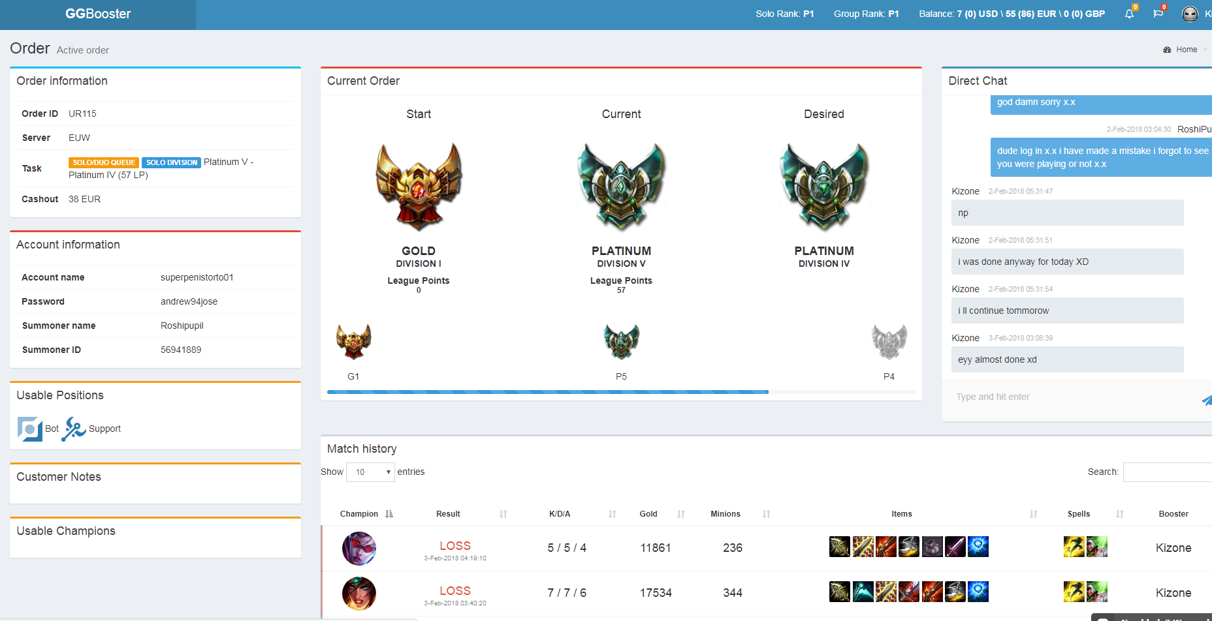
4. News Area: An area where the Admin write announcements for the Boosters.
5. Rules: I will provide you with a rule list soon.
6. Balance: 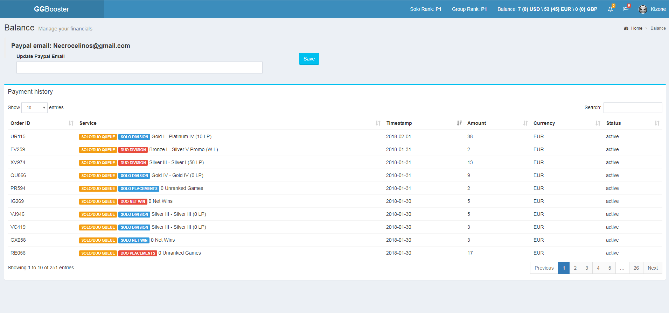The booster can update his Paypal Email address, where we will give their Cashout’s every week or 2 weeks. Currencies are different because customers pay in USD, EURO and Pound. The status will be set to “Paid” when we send the Cashout to their Paypal Address. It is possible for someone to have a negative Cashout, for example if the booster performed really bad and needs to get a fine/endorsement. After paying the salary of the booster, their available Balance will be reseted to 0, excluding the active orders.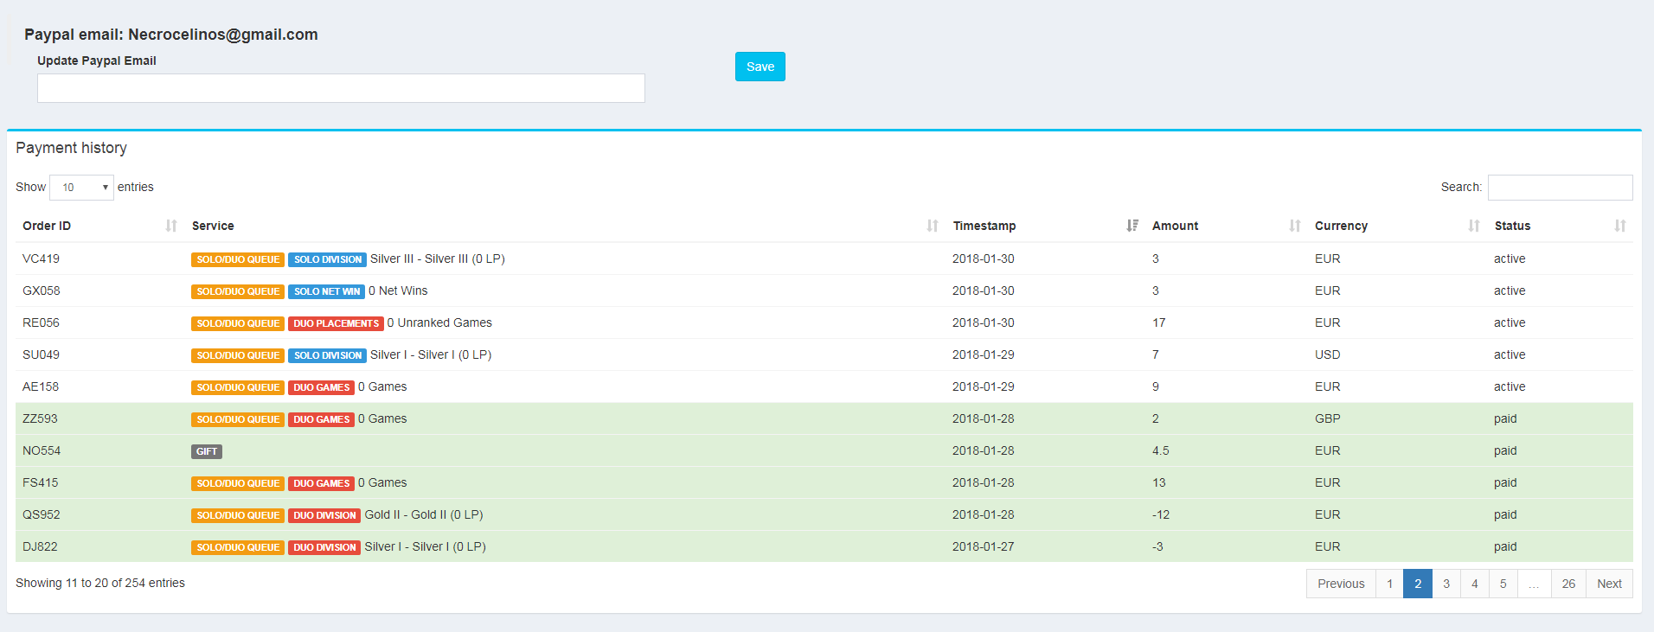
7. Booster’s Profile includes feedbacks from customers and overall Review/Score of the Booster.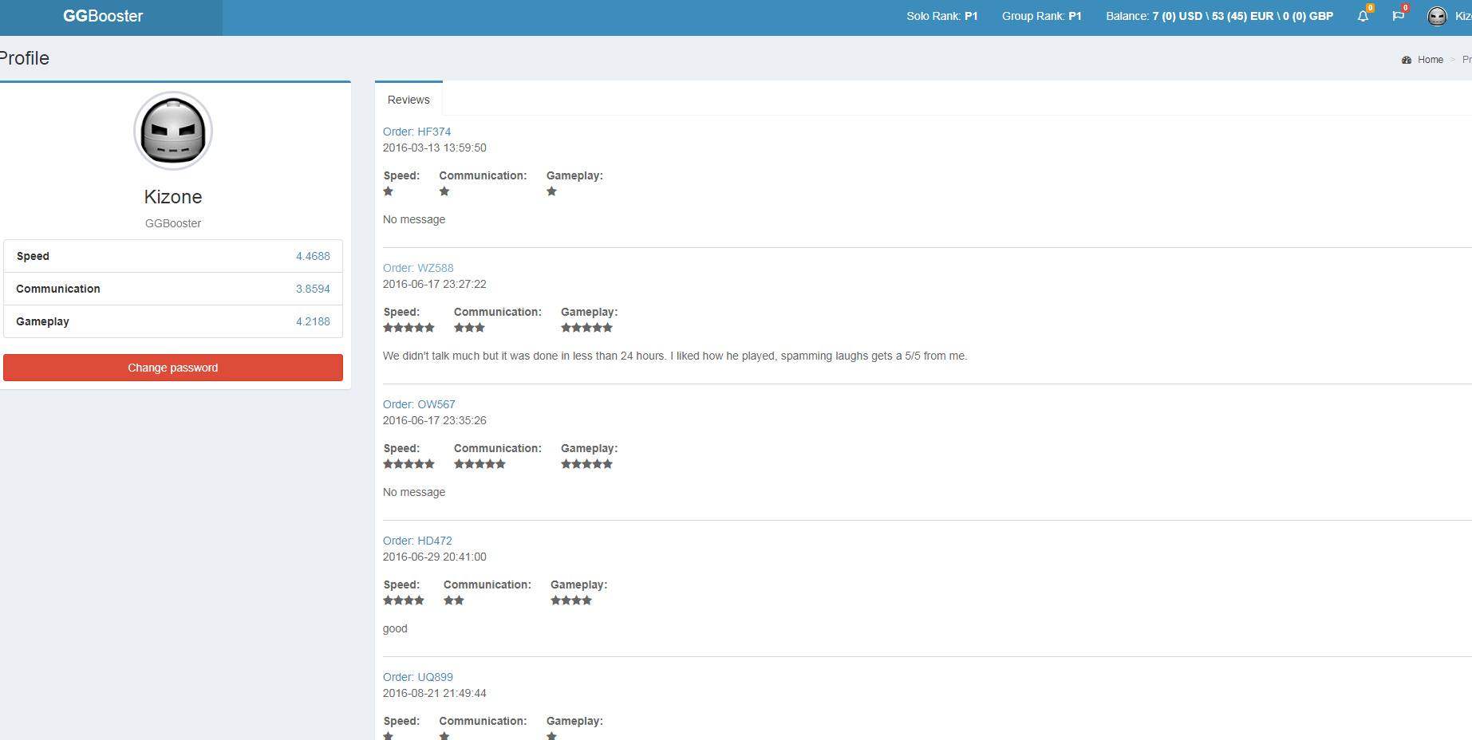
8. Booster’s Support chat. A chat-window to chat with the Admin. Booster’s Have frequently requests to Change the booster of the order, or any custom requests. 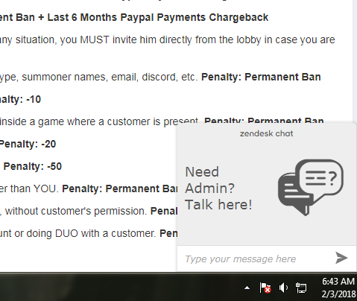
9. Near the News Area, the Admin should be able to create pop ups, Announcements, which the booster can right click or left click to make it disappear.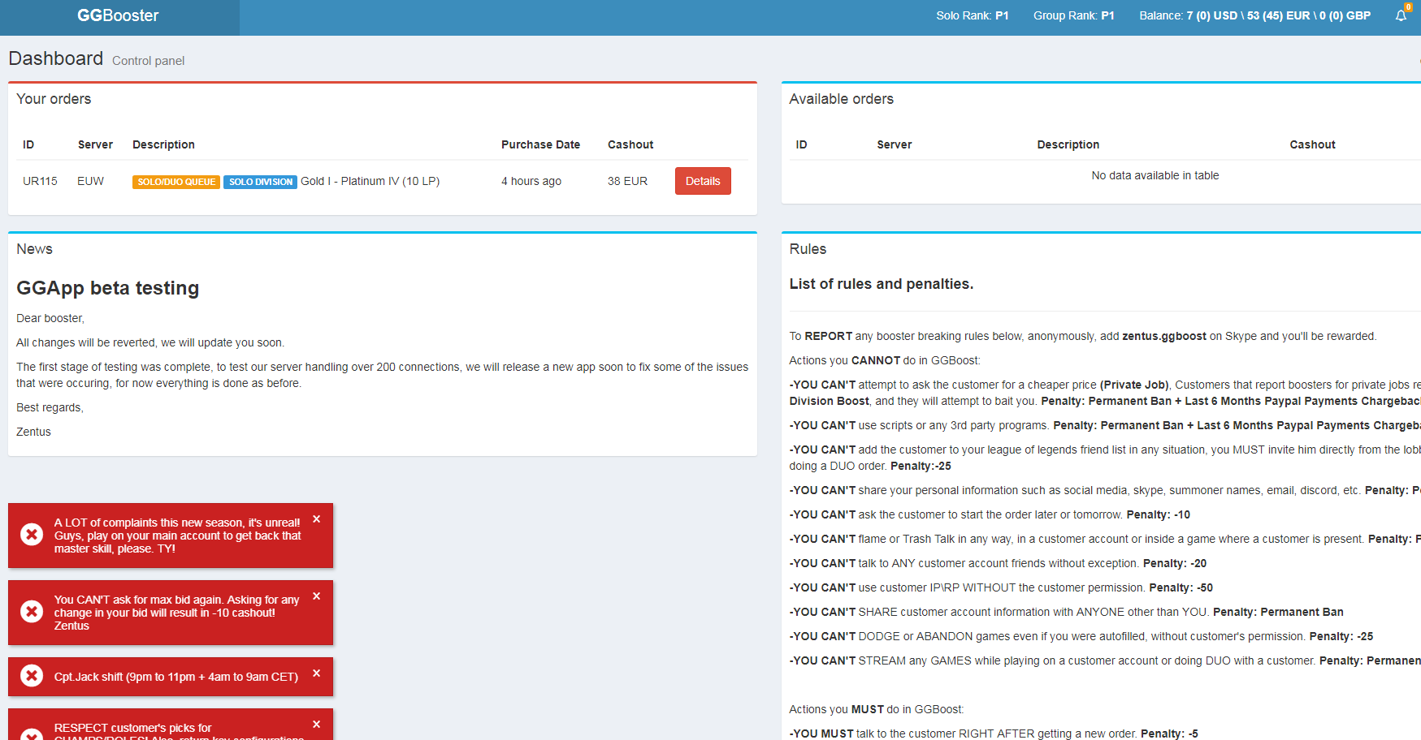

Member’s Area

<https://ggboost.com/demo>

Check every feature of the members area. In the boostexpress everything should include what is in this link. A Booster-Customer Chat, Account name, Password, Summoner name, Server, notes to booster, prefered champions, pause order, gift booster, and match history.

Admin’s Area

The Admin’s Area should be able to control to pause an order, see every order which are active, change the booster, change the order. The admin should be able to adjust everything what is possible to adjust given the information in the member’s area and booster’s area. And of course a chat where the customers and boosters are chatting with the admin.